CPE301 – SPRING 2025

Design Assignment 3

Student Name: Ryan Sewell

Student #: 8000473785

Student Email: sewelr2@unlv.nevada.edu

Primary Github address: https://github.com/sewelr2

Directory: DA-Submissions/DA3

Video Playlist:

<https://youtube.com/playlist?list=PLt45mEFhRV6ffOYRcGHhoI5aDeP3Zgqt5&feature=shared>

The goal of the assignment is use GPIO and delays using Timers and Interrupts:

1. Generate three delays using three timers T0, T3, and T4.
   1. Implement a delay of 0.125ms using Timer 0 in normal mode. Count OVF occurrence if needed. Do not use interrupts. Turn ‘on’ PB5 LED (also monitor and verify using logic analyzer) for approx. 1.5 sec and ‘off’ for 1.5 sec.
   2. Implement a delay of 0.250ms using Timer 3 TIMER3_COMPA_vect interrupt mechanism in CTC mode. Count OVF occurrence if needed in the IRQ subroutine. Turn ‘on’ PB4 LED (also monitor and verify using logic analyzer) for approx. 2 sec and ‘off’ for 2 sec.
   3. Implement a delay of 0.100ms using Timer 4 TIMER4_OVF_vect interrupt mechanism in normal mode. Count OVF occurrence if needed in the IRQ subroutine. Turn ‘on’ PB3 LED (also monitor and verify using logic analyzer) for approx. 1 sec and ‘off’ for 1 sec.
2. **COMPONENTS LIST AND CONNECTION BLOCK DIAGRAM w/ PINS**

Microchip Studio Atmega328PB-Xmini PC Multi-Function Shield Logic Analyzer

* Assembler - LEDs
* Simulator
* Debugger

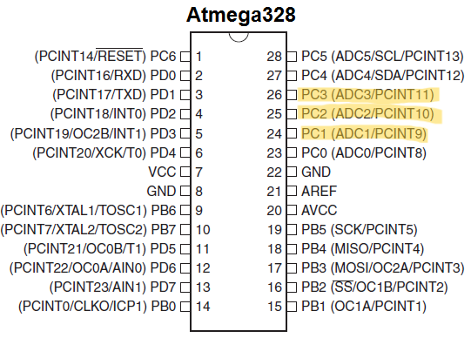

1. **INITIAL/MODIFIED/DEVELOPED CODE OF TASK 1/A**

#define F_CPU 16000000UL

#include <xc.h>

#include <avr/io.h>

#include <util/delay.h>

#define DELAY_125US_COUNT 12000 // 1.5 sec delay

int main(void)

{

DDRB |= (1 << PINB5); //Set PB5 as LED output

while(1)

{

// Turn on LED

PORTB |= (1 << PINB5);

for (uint16_t i = 0; i < DELAY_125US_COUNT; i++)

{

TCNT0 = 6; // Load 6 into TCNT0 to count 250 ticks

TIFR0 |= (1 << TOV0); // Clear timer0 overflow flag

TCCR0B = (1 << CS01); // Start Timer0 with prescaler = 8

// Wait for 125 us

while (!(TIFR0 & (1 << TOV0)));

}

PORTB &= ~(1 << PINB5); // Turn off LED

for (uint16_t i = 0; i < DELAY_125US_COUNT; i++)

{

TCNT0 = 6; // Load 6 into TCNT0 to count 250 ticks

TIFR0 |= (1 << TOV0); // Clear timer0 overflow flag

TCCR0B = (1 << CS01); // Start Timer0 with prescaler = 8

// Wait for 125 us

while (!(TIFR0 & (1 << TOV0)));

}

}

return 0;

}

1. **INITIAL/MODIFIED/DEVELOPED CODE OF TASK 1/B**

#include <xc.h>

#define F_CPU 16000000UL

#include <avr/io.h>

#include <avr/interrupt.h>

#include <avr/delay.h>

volatile uint16_t timer3_count = 0;

#define TIMER3_MAX_COUNT 8000 // 2 sec delay

ISR(TIMER3_COMPA_vect)

{

timer3_count++;

if (timer3_count >= TIMER3_MAX_COUNT)

{

PORTB ^= (1 << PINB4); // Toggle LED

timer3_count = 0;

}

}

int main(void)

{

DDRB |= (1 << PINB4); // Set PB4 as LED output

// Configure Timer3 for CTC mode

TCCR3A = 0; // Normal operation

TCCR3B = (1 << WGM32); // CTC mode

OCR3A = 499; // Prescaler set to 8, 500 ticks needed

TCCR3B |= (1 << CS31); // Start Timer3, prescaler = 8

TIMSK3 |= (1 << OCIE3A); // Enable Timer3 compare

sei(); // Enable global interrupts

while(1)

{

// Interrupt loop controls LED

}

return 0;

}

1. **INITIAL/MODIFIED/DEVELOPED CODE OF TASK 1/C**

/*

* main.c

*

* Created: 03/28/25 13:52:00

* Author: sewel

*/

#include <xc.h>

#define F_CPU 16000000UL

#include <avr/io.h>

#include <avr/interrupt.h>

volatile uint16_t timer4_count = 0;

#define TIMER4_MAX_COUNT 10000 // 1 sec delay (10000 * 100µs)

ISR(TIMER4_OVF_vect)

{

TCNT4 = 65336; // Load TCNT4 with 100 us period

timer4_count++;

if (timer4_count >= TIMER4_MAX_COUNT)

{

PORTB ^= (1 << PB3); // Toggle LED

timer4_count = 0;

}

}

int main(void)

{

DDRB |= (1 << PINB3); // Set PB3 as LED output

TCCR4A = 0; // Timer4 normal mode

TCCR4B = (1 << CS41); // Start Timer4 with prescaler = 8

TCNT4 = 65336; // Load Timer4 for the first overflow after 100us

TIMSK4 |= (1 << TOIE4); // Enable Timer4 overflow interrupt

sei(); // Enable global interrupts

while(1)

{

}

return 0;

}

1. **SCHEMATICS**

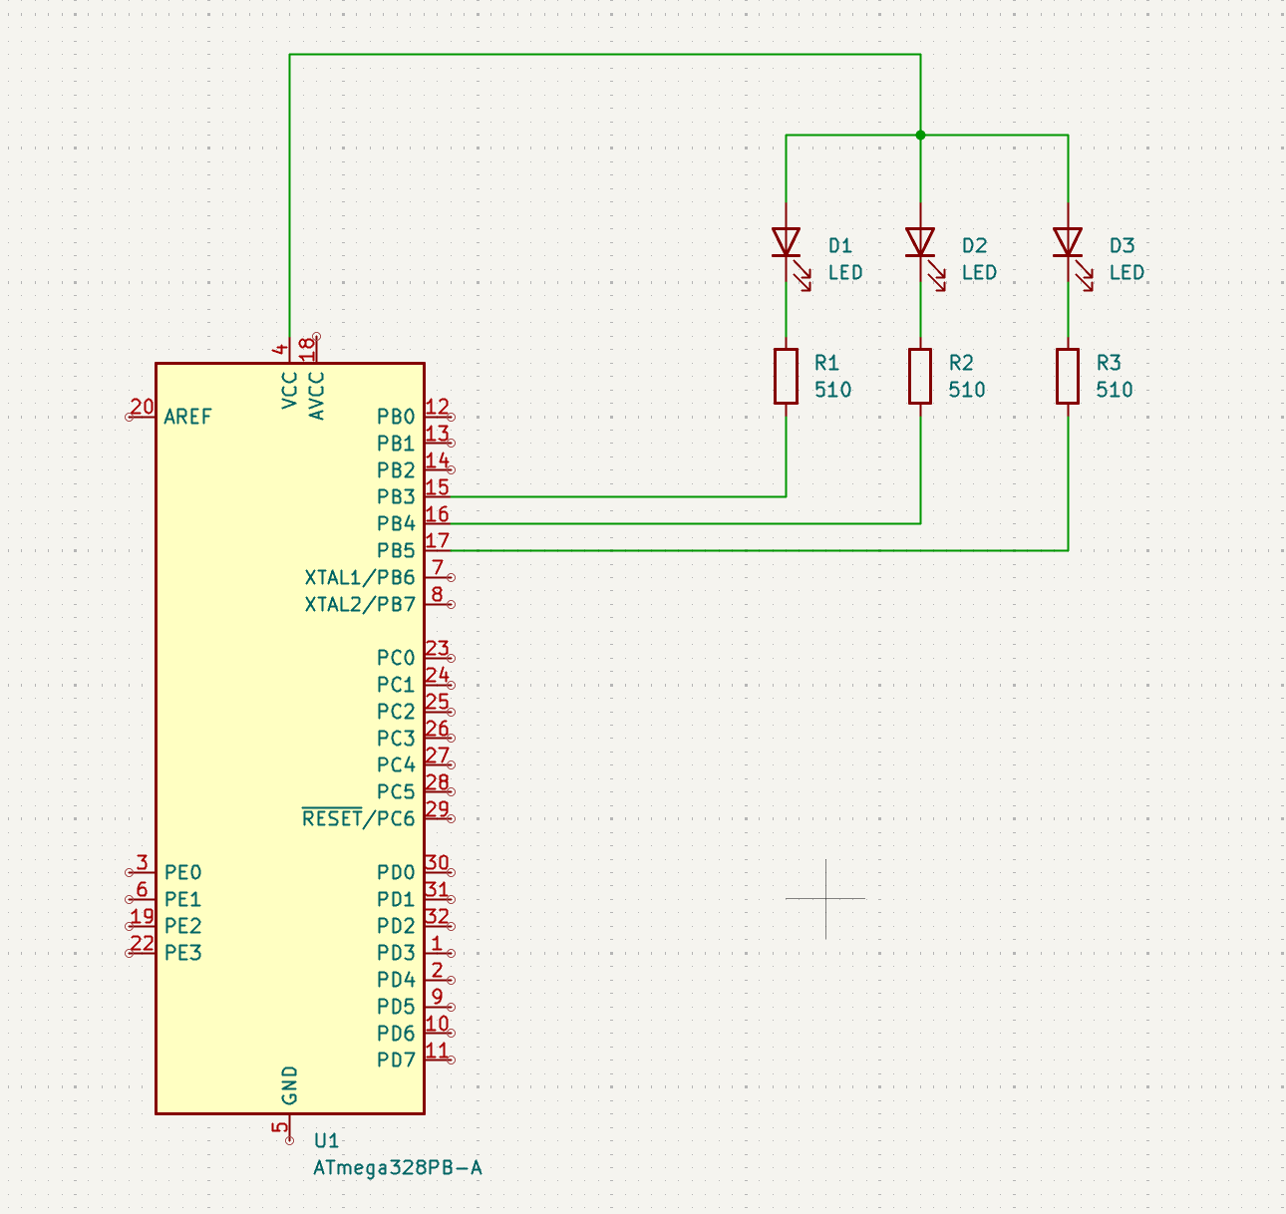

1. **SCREENSHOTS OF EACH TASK OUTPUT (ATMEL STUDIO OUTPUT)**

Task 1:

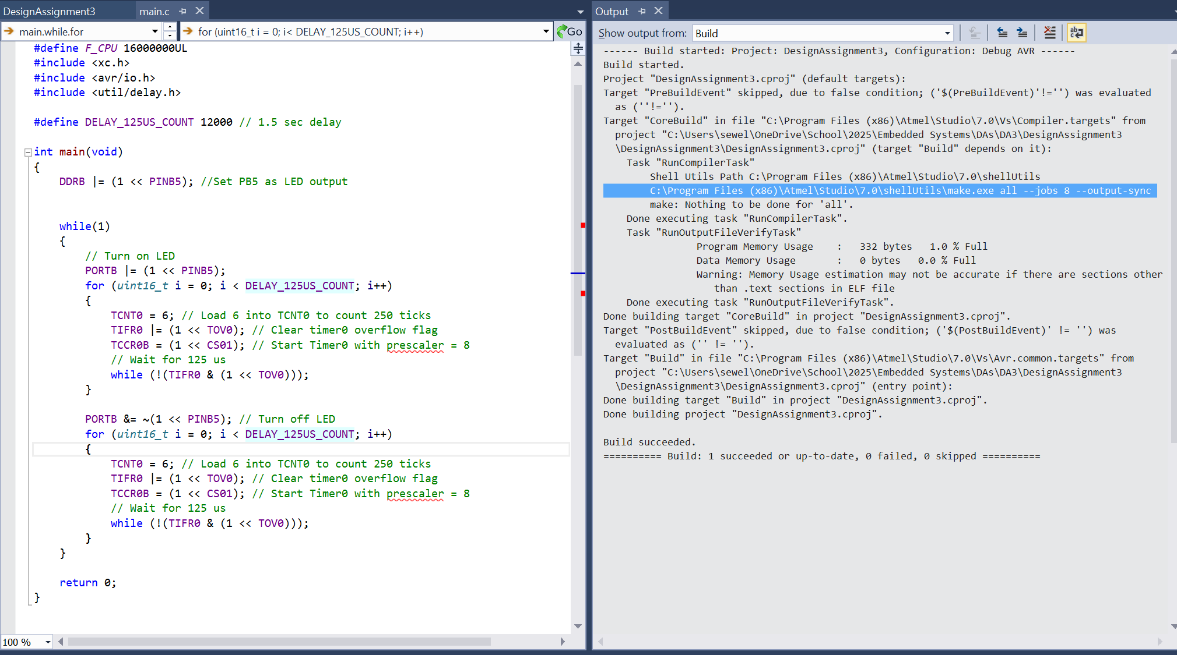

Task 2:

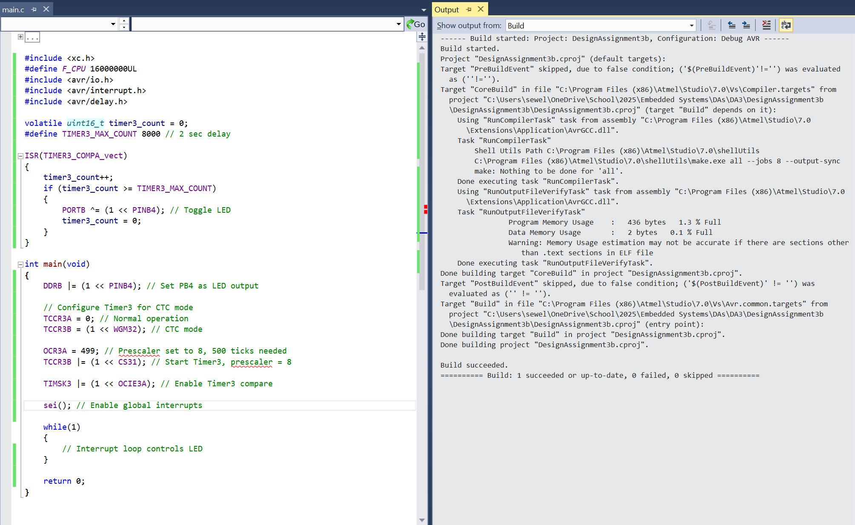

Task 3:

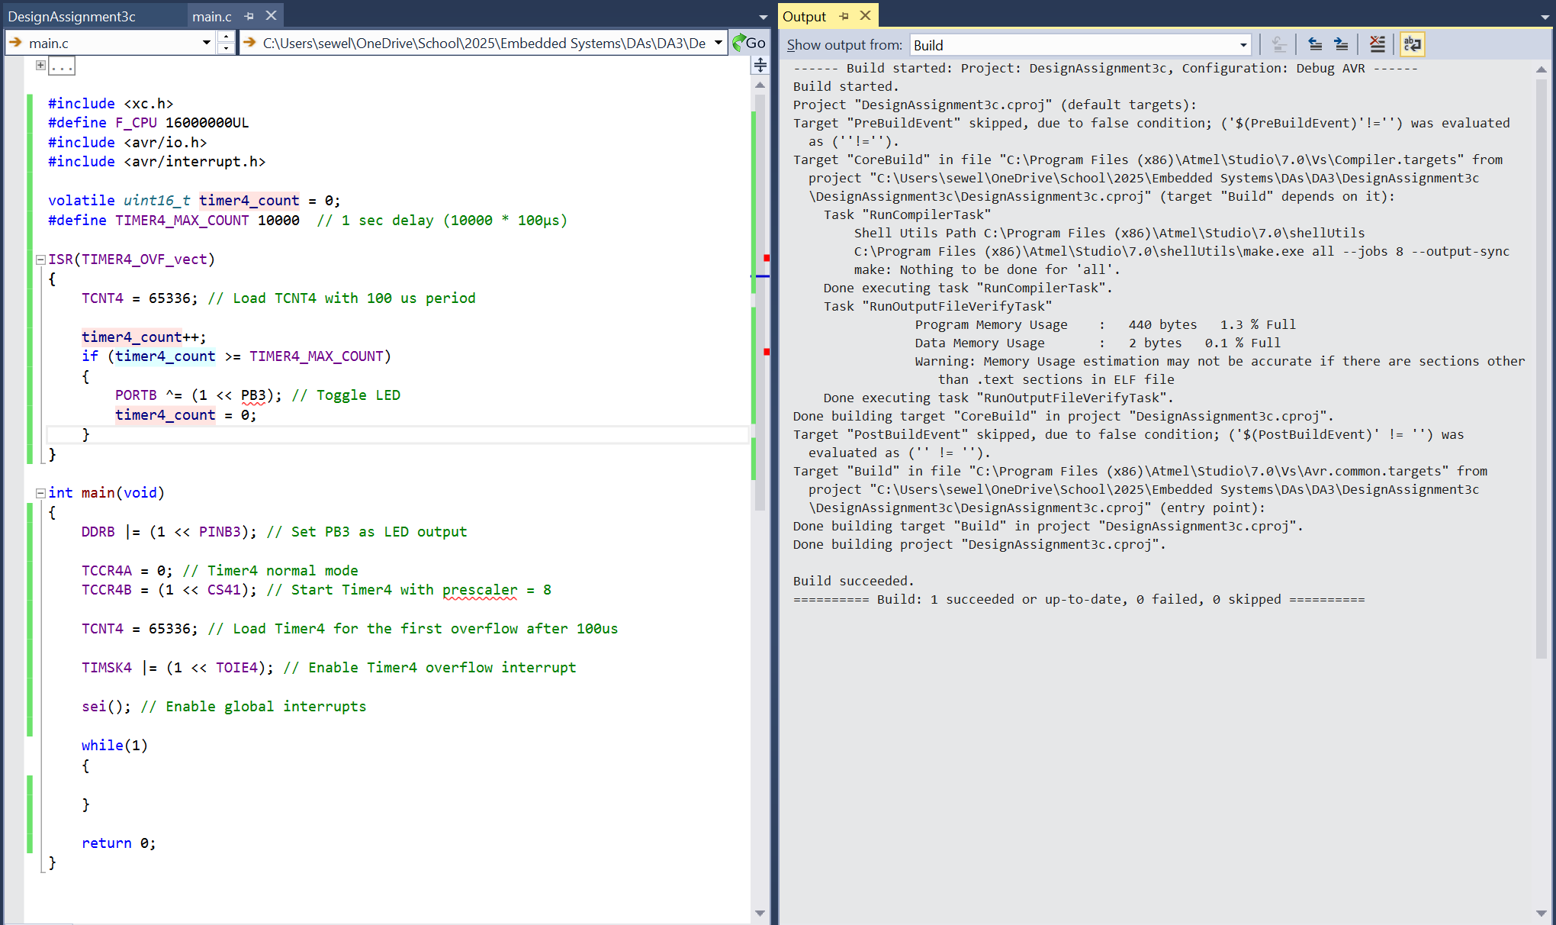

1. **SCREENSHOT OF EACH DEMO (BOARD SETUP)**

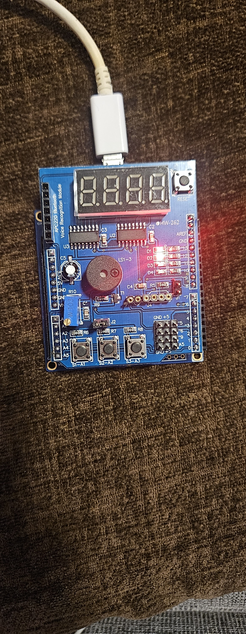

Task 1:

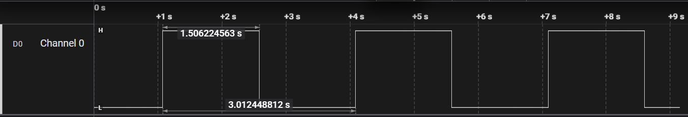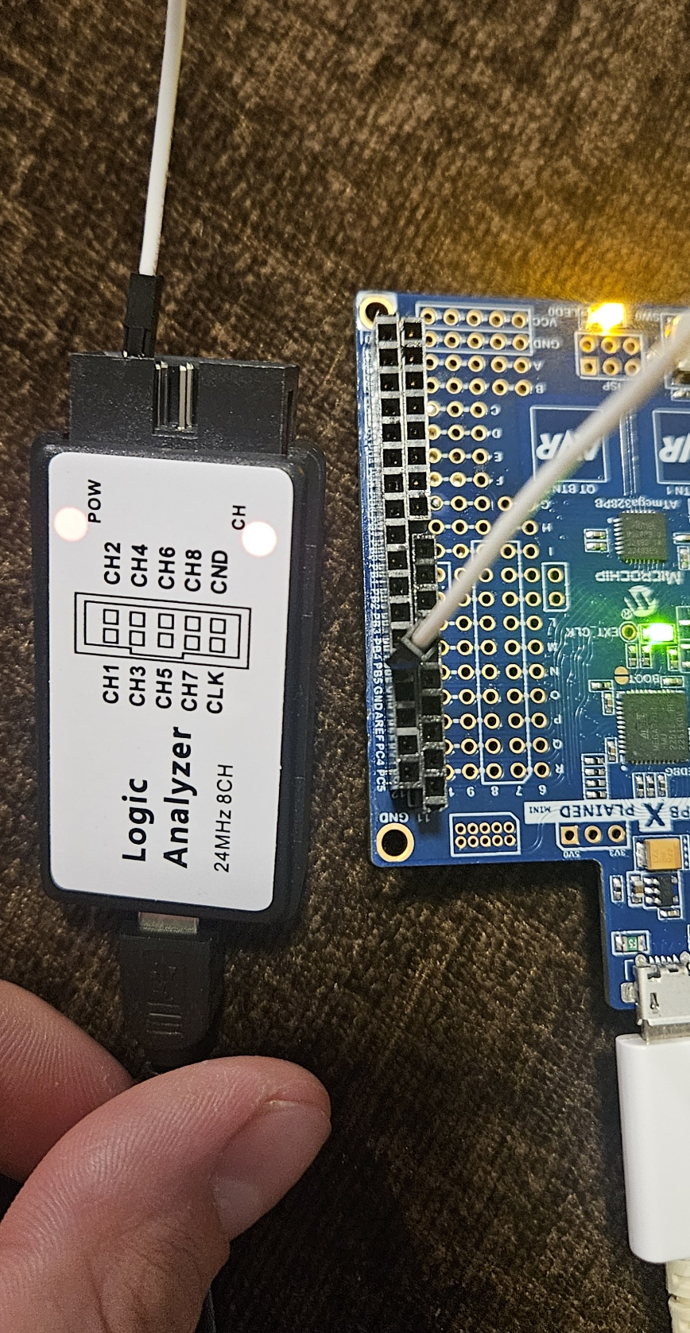

Task 2:

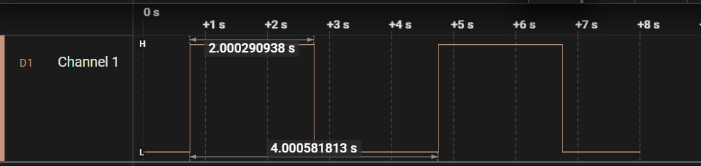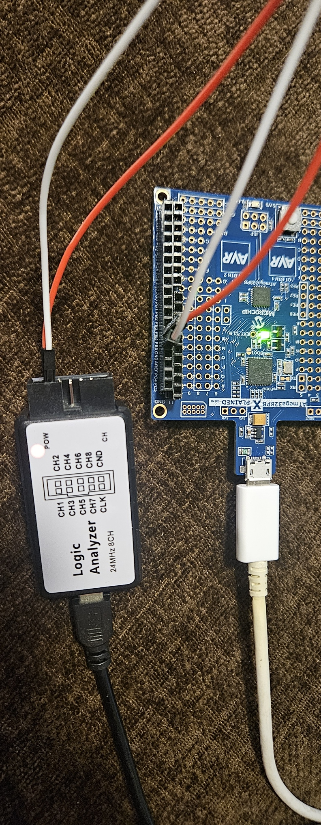

Task 3:

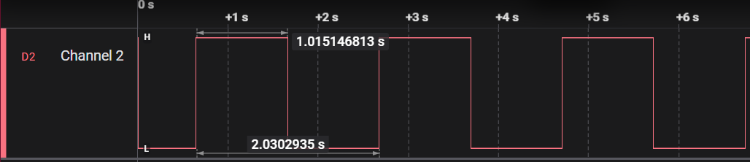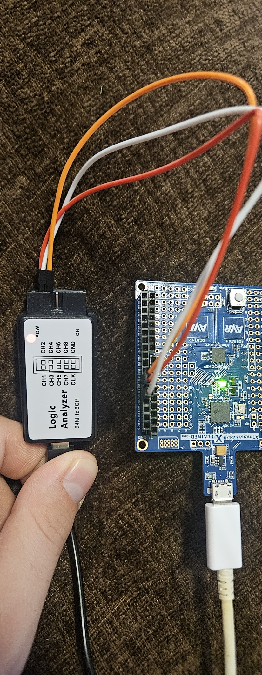

1. **VIDEO LINKS OF EACH DEMO**

All tasks in one video

Link:

https://youtu.be/TaM0TgI6_yo

1. **GITHUB LINK OF THIS DA**

Task 1:

Task 2:

…

**Student Academic Misconduct Policy**

<http://studentconduct.unlv.edu/misconduct/policy.html>

“This assignment submission is my own, original work”.

Ryan Sewell